**Project Title:** Smart Farmer – IoT Enabled **Project Design Phase-I** - **Solution Fit Team ID:PNT2022TMID36343**

Smart Farming Application

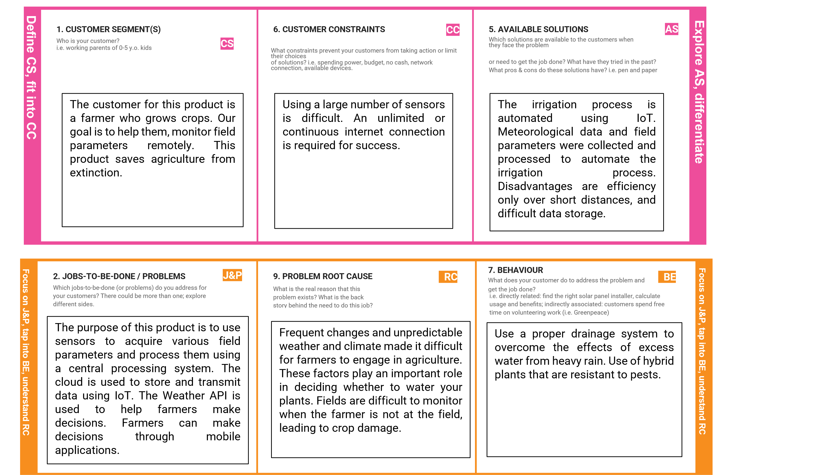



**I**

**d**

**e**

**n**

**ti**

**f**

|  |  |  |  |  |  |  |  |  |  |  |  |
| --- | --- | --- | --- | --- | --- | --- | --- | --- | --- | --- | --- |
|  |  | | | |  | | |  | | |  |
| **3. TRIGGERS** | **TR** |  | | **10. YOUR SOLUTION** | **SL** |  | **8. CHANNELS of BEHAVIOUR** | **CH** |  |
| What triggers customers to act? i.e., seeing their neighbor installing solar | | | | If you are working on an existing business, write down your current | | | **8.1 ONLINE** | | |
| panels, reading about a more efficient solution in the news. | | | | solution first, fill in the canvas, and check how much it fits reality. If you are working on a new business proposition, then keep it blank until you fill in the canvas and come up with a solution that fits within customer limitations, solves a problem and matches customer behaviour.     |  | | --- | | Our product collects data from various types of sensors and sends the values to our main server. It also collects weather data from the Weather API. The final decision to irrigate the crop is made by the farmer using a mobile application. | | | | What kind of actions do customers take online? Extract online channels from #7    **8.2 OFFLINE**  What kind of actions do customers take offline? Extract offline channels from #7 and use them for customer development.   |  | | --- | | ONLINE: Providing online assistance to the farmer, in providing knowledge regarding the pH and moisture level of the soil. Online assistance to be provided to the user in using the product    OFFLINE: Awareness camps to be organized to teach the importance and advantages of the automation and IoT in the development of agriculture. | | | |
| Farmers struggle to provide adequate irrigation. Inadequate water supply reduces yields and affects farmers' profit levels. Farmers have a hard time predicting the weather. | | |  |
|  | | | |
| **4. EMOTIONS: BEFORE / AFTER** | **EM** |  | |
| How do customers feel when they face a problem or a job and afterwards? | | | |
| i.e. lost, insecure > confident, in control - use it in your communication strategy & design.     |  | | --- | | BEFORE: Lack of knowledge in weather forecasting →Random decisions →low yield.  AFTER: Data from reliable source → correct decision →high yield | | | | |